Team Pisces

**Installation Guide**

1. Double click on the instillation file.  
   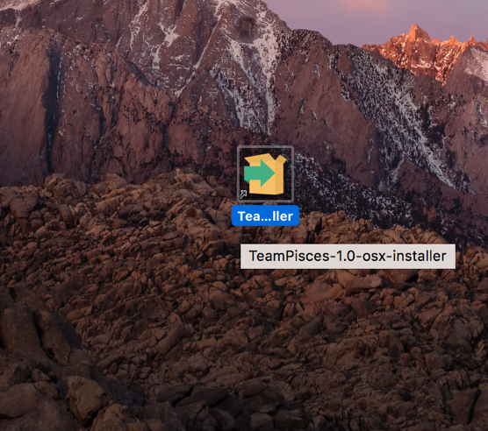
2. A splash screen with the Galaxy Logo will appear for one second and then disappear.  
   
3. A setup screen will appear. Click the “Next >” button to continue.   
   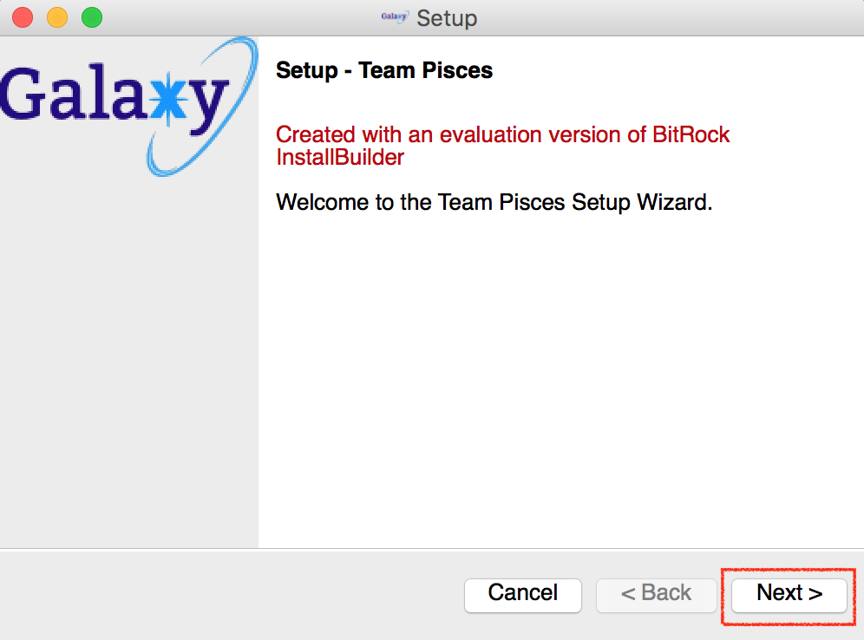
4. The Installation Directory will ask where to install the program. Click “Next >” button to continue.   
   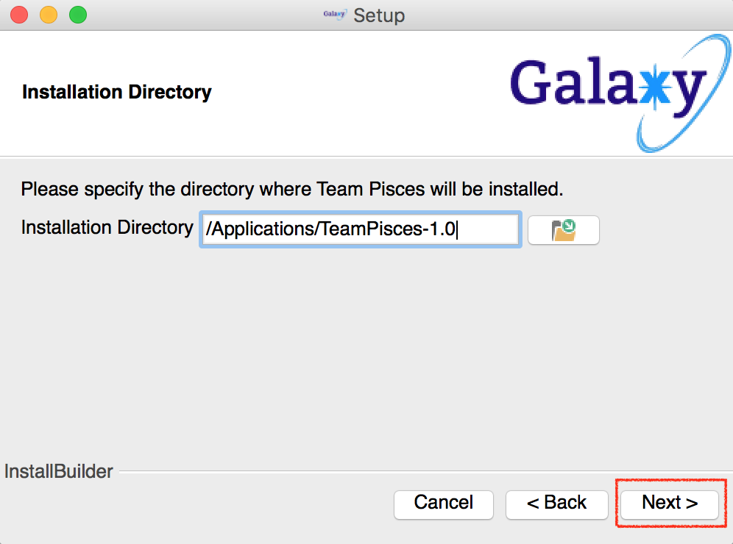
5. The Ready to Install screen will appear. Click “Next >”button to continue to install.  
   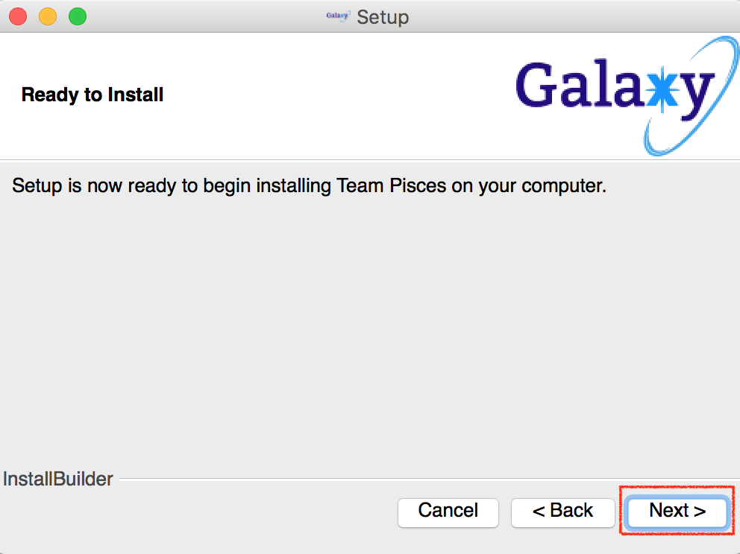
6. The installation will start and may take up to 30 seconds to install.  
   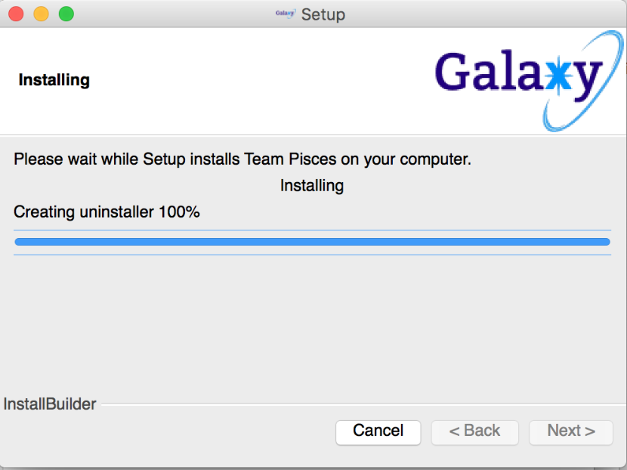
7. Installation is complete. Click “Finish” button to complete the process.  
   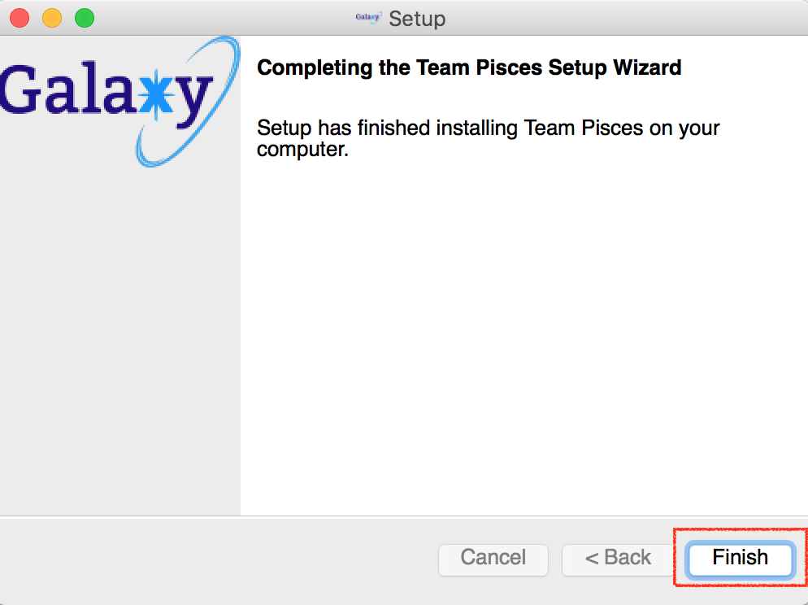
8. Go to Application Folder(MacOS)/Program File x86 Folder(Windows) to view the program and the uninstall file.
9. Double click “TeamPisces” to start the program.